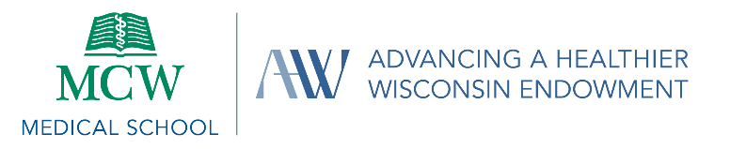

NOTICE OF MEETING OF

THE BOARD OF DIRECTORS OF MCW CONSORTIUM ON PUBLIC AND COMMUNITY HEALTH, INC.
Notice is hereby given of a meeting of the Board of Directors of MCW Consortium on Public and Community Health, Inc., to be held at 2:00 PM on May 7, 2026 via Zoom web meeting/conference (Join via link. (Passcode: iBhEi1R9). In accordance with Wisconsin open meetings laws, members of the public are welcome to join, but not participate in this meeting.

AGENDA

CALL TO ORDER

APPROVAL OF MARCH 5, 2026, CONSORTIUM MINUTES

PROGRAMMATIC UPDATE

Review Financial Projections

DECISION MAKING

2026 Momentum Grant Review

2027 Seed Grant Allocation Approval

INTERIM EXECUTIVE DIRECTOR’S REPORT

AHW Executive Director Search Update

ADJOURN

Please note: This agenda is subject to change. Please refer to the Consortium’s website for updated information.

